# 

Beyond Aesthetics: a comparative analysis of Web Design Trends and User Preferences.

**VICTOR DANIEL BUCUR**

20211235

*Supervisor:* ***Dr Neil Buckley***

*Submitted May 2024*

*Department of****Mathematics, Computer Science, and Engineering***

*Liverpool Hope University*

**Declaration**

This dissertation is submitted in partial fulfilment of the requirements for the Master of Science degree at the School of Mathematics, Computing and Engineering, Liverpool Hope University.

I hereby certify that this work is entirely my own, and I have cited all sources, as necessary.

The word count for this dissertation including title page, declaration, abstract, acknowledgements, table of contents, list of illustrations, references and appendices is 8858.

I also permit Liverpool Hope University to store a copy of this dissertation in a public archive.

# 

# **Abstract**

The transformation of web design from basic text pages to complex, interactive platforms mirror the rapid evolution of digital technology and changing user behaviours. This dissertation delves into the journey of web design, emphasizing its pivotal role in shaping user experience across the vast digital landscape. With the internet infiltrating every aspect of modern life, the demand for functional, aesthetically pleasing, and accessible web interfaces has skyrocketed. This study aims to uncover the technological advancements, design philosophies, and user engagement strategies that have marked the evolution of web design from its inception to the present day. By examining historical trends and socio-technical contexts, it seeks to provide insights into the interplay between design innovation and digital communication. A practical project component applies these findings, focusing on developing a fan engagement website for FC Barcelona, incorporating cutting-edge web design techniques to enhance interactivity and user connection. This research underscores the significance of embracing responsive, inclusive, and sustainable web design principles to meet current challenges and anticipate future developments in the digital domain, offering a roadmap for creating more engaging and meaningful online experiences.

**Table of Content**

Abstract 3

Chapter 1 5

1. Introduction 5

**1.1 Background and Motivation** 5

**1.2 Aims and Objectives** 6

2. Historical Overview of Web Design Trends 6

**2.1 The Dawn of the Web (1989-1995)** 6

**2.2 The Rise of Interactivity and social media (1996-2006)** 8

**2.3 Advancements in Web Technologies and the Era of Mobile Internet (2007-2020s)** 9

Chapter 2 9

Literature review 9

**1.** **Beyond Aesthetics: Web Design Trends** 10

**1.1 The Impact of Web Design on User Behaviour** 10

**1.2** **Current Trends in Web Design** 10

**1.2.1 Minimalism and User Experience** 10

**1.2.2 Mobile-First Design** 11

**1.2.3 Interactive and Dynamic Elements** 11

**1.2.4 Accessibility and Inclusivity** 11

**1.2.5 Sustainable Web Design** 11

**2.** **User Preferences** 12

**2.1 The Role of User Preferences in Product Design** 12

**2.2 User Preferences in Digital Interfaces** 13

**3.** **Analysing and Collecting User Preferences** 14

**4.** **The Future of Web Design and User Preferences** 15

Chapter 3 16

1. Introduction into Methodology 16

2. Planning Phase 17

3. Tools to be used. 20

4. Implementation 21

**4.1 Main page** 21

**4.2 Shop** 23

**4.3 Players Page** 24

**4.4 Fixtures** 26

**4.5 Quiz** 27

5. Limitations 29

Chapter 4 31

Conclusion 31

References 32

# **Chapter 1**

## **Introduction**

### **1.1 Background and Motivation**

The transformation of the World Wide Web from its inception in the late 20th century to the current era has been profound and multifaceted, touching every aspect of human interaction with digital technology. From its humble beginnings as a text-based information-sharing platform, the web has evolved into a complex, dynamic, and visually rich medium, offering a gateway to an endless array of multimedia content and interactive experiences. This evolution has been driven by rapid advancements in technology, shifts in user behaviour and expectations, and the growing significance of the internet in everyday life. The web today is a place where we live, work, and play, making its design more important than ever.

As the digital landscape became more sophisticated, so did the field of web design, evolving from simple, linear layouts to intricate designs that prioritize user experience, aesthetic appeal, and functionality. This journey through web design's history not only mirrors the technological advancements of the times but also reflects the changing cultural and social norms, making it a subject worthy of deep academic exploration.

The pivotal role of web design in shaping the digital user experience cannot be understated. With the internet's expansion into every facet of modern life, from education and healthcare to commerce and entertainment, the importance of effective, engaging, and accessible web design has become increasingly paramount. Thus, understanding the evolution of web design is not just an exercise in historical analysis but a crucial inquiry into the forces shaping our digital future.

### **1.2 Aims and Objectives**

This dissertation aims to dissect the evolution of web design from 1990 to the present day, providing a comprehensive analysis of the technological innovations, design philosophies, and user experience strategies that have defined each era of web development. By examining the key milestones in web design and the socio-technical context surrounding these developments, this study seeks to offer insights into the interplay between technology and design aesthetics, as well as the impact of web design trends on user engagement and digital communication.

The objectives of this dissertation are as follows:

* To chart the historical progression of web design, identifying key technological advancements and design trends that have influenced the look, feel, and functionality of web interfaces.
* To analyse the impact of web design evolution on user experience, including how design choices have adapted to changing user expectations and technological capabilities.
* To explore the socio-cultural implications of web design trends, considering how shifts in design philosophy reflect broader changes in society and technology usage.
* To assess the future trajectory of web design, evaluating emerging technologies and design approaches that are likely to shape the digital landscapes of tomorrow.

## **Historical Overview of Web Design Trends**

Rob Ford and Julius Wiedemann’s "Web Design: The Evolution of the Digital World 1990–Today," alongside Helen Kennedy’s insightful "Net Work : Ethics and values in web design" provide a thorough exploration of this transformative journey. They delve into the intricate dance between web design’s technological evolution and its socio-cultural ramifications. Complementing these scholarly insights, the website Web Site Museum “<https://www.webdesignmuseum.org/>” offers a visual testament to this evolution, showcasing high-quality images that illustrate the dramatic shift in web design aesthetics and functionality over the decades.

### **2.1 The Dawn of the Web (1989-1995)**

In 1989-1990, Tim Berners-Lee at CERN introduced the World Wide Web, launching the first website and setting a foundational framework with HTML and HTTP. This period was characterized by simplicity and functionality, with web design focused on text-based content and hyperlinking for global information access. The early nineties saw the web evolving from text-only pages to incorporating the first photograph on a website in 1992, symbolizing a shift towards a more visually engaging web. The release of Mosaic in 1993 further catalysed this evolution by supporting images alongside text, marking the beginning of the internet's transformation into a visually rich medium. By 1994, the internet's commercial potential began to be realized with the launch of Netscape Navigator and Yahoo!, alongside the first secure online transaction on Netscape, signalling the web's significant strides toward commercialization and enhanced user experience.

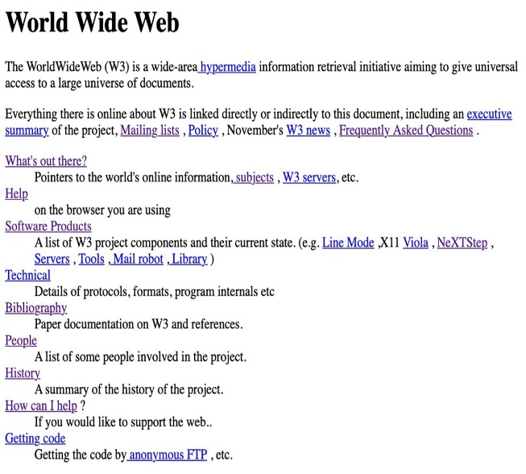

Figure 1: First website



Figure 2: First image online

### **2.2 The Rise of Interactivity and social media (1996-2006)**

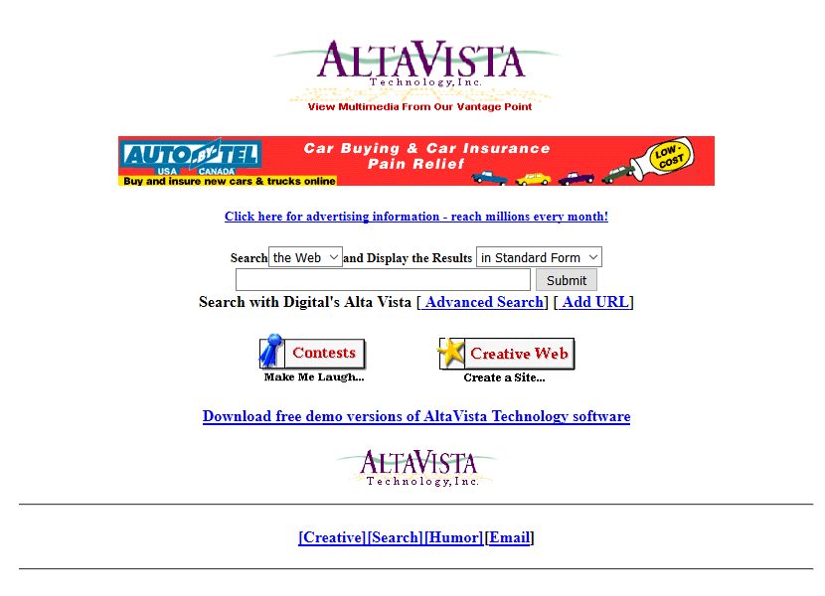The late 90s and early 2000s were marked by significant technological advancements that shaped user interaction and web design. The launch of Hotmail in 1996 introduced webmail services, expanding communication possibilities, while the emergence of Flash animations in 1997 added a new dimension to web interactivity and design. The foundation of Google in 1998 revolutionized web search, setting new standards for information retrieval and accessibility. This period also witnessed the rise of social media, with platforms like Facebook and YouTube transforming web engagement and design paradigms. The introduction of CSS and the widespread adoption of broadband internet facilitated more complex, visually appealing, and user-friendly web designs, marking a transition towards more dynamic and interactive web experiences.

Figure 3 : Alta Vista December 1996

### **2.3 Advancements in Web Technologies and the Era of Mobile Internet (2007-2020s)**

The late 2000s and early 2020s saw web development technologies evolve rapidly with the introduction of jQuery in 2006, facilitating easier interaction with web documents, and the groundbreaking launch of Node.js in 2009, allowing JavaScript usage server-side. This era also heralded the significant influence of HTML5, finalized in October 2014, which alongside CSS3 and advancements in JavaScript frameworks like AngularJS and React, pushed web applications to new heights of interactivity and user engagement. The integration of AI and machine learning personalized user experiences, while regulatory measures like GDPR reshaped web development practices towards greater transparency and user privacy..

After 2020, the world witnessed a remarkable integration of immersive technologies and **the Internet of Things** (IoT) into the realm of web development. In the early 2020s, augmented reality (AR) and virtual reality (VR) emerged as key influences in web design. These technologies brought about a new era of immersive experiences, revolutionizing how users interacted with digital content. Particularly noteworthy was the adoption of AR in e-commerce platforms, where virtual try-on features significantly enhanced the online shopping experience.

Simultaneously, the Internet of Things (IoT) began reshaping our understanding of web interfaces. With an increasing variety of devices, ranging from smartwatches to household appliances, becoming connected to the internet, web design expanded its focus. It was no longer solely about traditional computers and smartphones, the landscape broadened to include a diverse array of internet-enabled devices, necessitating more versatile and adaptive web interfaces.

# **Chapter 2**

## **Literature review**

The intersection of visual web design and user experience is a pivotal area of study, where aesthetics directly influence user satisfaction and website evaluation. This relationship is detailed in the 2022 Journal of Marketing Management article, emphasizing the role of aesthetics in usability and pleasure, thereby affecting user evaluations of websites. Complementing this view, "Beyond Aesthetics: The Deeper Impact of UX/UI Design Principles" by Mr. Pursho explores how UX/UI design extends beyond visual appeal to impact user psychology and behaviour.

Foundational texts enrich our understanding of this field: Clarissa Peterson's "Learning Responsive Web Design: A Beginner's Guide", Robbins Jennifer “Learning Web Design: A Beginner's Guide to HTML, CSS, JavaScript, and Web Graphics” and Ethan Marcotte's "Responsive Web Design" emphasize the importance of adaptability in design. Steve Krug's "Don't Make Me Think" advocate for user-friendly and intuitive design principles. Furthermore, Jon Duckett's "HTML & CSS: Design and Build Websites" underscores the technical essentials of creating visually appealing and functional sites.

### **Beyond Aesthetics: Web Design Trends**

### **1.1 The Impact of Web Design on User Behaviour**

Web design significantly influences user behaviour and engagement, transitioning from an aesthetic focus to prioritizing usability and accessibility. As Jennifer Robbins highlights in "Learning Web Design: A Beginner's Guide to HTML, CSS, JavaScript, and Web Graphics," good web design, characterized by intuitive navigation and clear calls-to-action, encourages visitor engagement, leading to actions such as purchases or newsletter sign-ups. Conversely, poor design can frustrate users and increase bounce rates. The strategic use of design elements like colour, typography, and imagery is essential in conveying a brand's message and influencing emotional responses, which in turn builds trust and credibility.

Robbins also points out that the evolution of web design mirrors this shift in priorities. Early websites were text-heavy and limited in graphics, focusing on information delivery. With technological advancements, web design embraced more complex aesthetics, including animations and graphics. However, this trend often compromised usability and speed .

“The rise of smartphones means that more and more people are going online from mobile devices. According to Pew Internet, 57% of Americans said they would use a mobile device to access the internet in 2013. A surprisingly large number , 34%, of these mobile Internet users said that was the primary way to access the web” ( Peterson, 2014, p.176), that means the rise of mobile internet usage has further influenced web design, emphasizing responsive and adaptive designs for seamless user experiences across devices. Modern web design harmonizes aesthetics with functionality, ensuring intuitive navigation, fast loading times, and accessible content. Understanding and adapting to these trends is essential for anyone looking to establish a meaningful online presence. (Peterson, 2014)

### **Current Trends in Web Design**

### **1.2.1 Minimalism and User Experience**

Minimalism in web design champions simplicity and clarity. This trend focuses on using essential elements, clean lines, and ample white space to create a serene and uncluttered user interface. The philosophy behind minimalism is “less is more”, emphasizing content over decorative elements. By reducing distractions, minimalist designs facilitate quicker loading times and easier navigation, enhancing the overall user experience. This approach not only appeals to the aesthetic senses but also significantly improves website usability, especially in an era where attention spans are short, and users appreciate direct, clear messaging (Peterson, 2014).

### **1.2.2 Mobile-First Design**

Mobile-first design is not just a trend but a necessity in today's digital landscape. With most of the internet traffic coming from mobile devices, designers are prioritizing mobile experiences before scaling up to larger screens. This approach involves designing for smaller screens with touch interfaces, considering factors like thumb-friendly navigation, easily readable fonts, and optimized images for faster loading. Mobile-first design ensures that websites are inherently responsive, providing a consistent and seamless experience across all devices. It reflects an understanding of modern browsing habits and tailors the design to meet users where they are most active (Peterson, 2014).

### **1.2.3 Interactive and Dynamic Elements**

Interactive and dynamic elements in web design are becoming increasingly popular, offering users an engaging and memorable experience. This includes animations, hover effects, scrolling transformations, and even virtual or augmented reality integrations. Such elements make a website feel alive and responsive to user interactions, creating a more immersive experience. However, the key is to use these features judiciously to enhance, not hinder, the user experience. Well-implemented dynamic elements can guide users through a website, highlight important information, and add a layer of interactivity that makes the user journey more enjoyable and engaging (Robbins, 2018; Peterson, 2014).

### **1.2.4 Accessibility and Inclusivity**

Accessibility and inclusivity in web design are critical trends, ensuring that websites are usable by everyone, including people with disabilities. This involves designing websites that are navigable and readable through screen readers, providing alternative text for images, ensuring high contrast between text and background, and creating keyboard-friendly site navigation. Inclusivity also extends to considering diverse user groups, accommodating different languages, cultures, and age groups. Prioritizing accessibility not only broadens the audience reach but also reflects a commitment to social responsibility. It is about creating a digital world that's open and accessible to all, aligning with broader societal shifts towards inclusivity (Robbins, 2018).

### **1.2.5 Sustainable Web Design**

Sustainable web design is a thoughtful approach to creating digital products that consider environmental impact, efficiency, and user inclusivity. It is about designing websites that are energy-efficient, minimizing their carbon footprint while still being effective and engaging for users. Key practices include optimizing images and videos for faster load times and reduced data consumption, efficient coding to reduce server load, and using eco-friendly web hosting powered by renewable energy sources. “Sustainable web design is an approach to designing web services that puts people and planet first. It delivers digital products, services, and data that respect the principles of the Sustainable Web Manifesto: clean, efficient, open, honest, regenerative, and resilient.” (<https://sustainablewebdesign.org/> , 2024).

### **User Preferences**

In terms of resources for further exploration into these trends, two notable books can be helpful. "Don't Make Me Think" by Steve Krug is a classic in the field of web usability, offering timeless principles that are increasingly relevant in the context of these emerging trends. Another insightful resource is "Responsive Web Design" by Ethan Marcotte. This book delves into the principles of creating web designs that adapt to various devices and screen sizes, a concept that is central to modern web design trends, especially considering the growing emphasis on mobile-first design.

User preferences are the specific tendencies, inclinations, and choices that individuals exhibit towards various aspects of products and services. These can range from simple colour choices to complex interaction styles with technology, influenced by factors like cultural background, personal experiences, and demographic characteristics. For instance, younger users might gravitate towards fast-paced, interactive digital experiences, while older demographics may prefer simplicity and ease of use. Behavioural preferences also play a key role, including how users interact with products or services, like frequency of use, communication channels, and responsiveness to content.

In web design, these preferences are especially crucial. Research shows that user purposes for web use, such as information seeking, entertainment, e-commerce, or communication, significantly influence their preferences for web design features like content quality, accessibility, navigation, visual appeal, and security. A deeper understanding of these purposes allows for a more tailored and effective web design, enhancing user satisfaction and engagement. For businesses, adapting to these evolving preferences, shaped by trends and technological advancements, is vital for developing personalized, relevant products and services. Recognizing the dynamic nature of user preferences, and their deep impact on web design choices, is therefore a cornerstone of successful user-centred design and business strategy.

### **2.1 The Role of User Preferences in Product Design**

### 

In product design, understanding and integrating user preferences is critical for creating successful products. Designers must delve beyond superficial likes and dislikes, exploring the deeper motivations and needs of their target audience. This requires a holistic approach, considering not just aesthetics but also functionality, usability, and emotional resonance. For instance, in designing a smartphone, it is not enough to focus on technical specifications. Designers must also consider how users prefer to interact with their devices. Do they prioritize camera quality for social media use, or do they need long battery life for productivity? Understanding these preferences can lead to design choices that make the product more appealing and useful to its intended audience. Furthermore, cultural nuances play a significant role. A colour or design element might be appealing in one culture but not in another. Similarly, ergonomic design must consider various physical attributes of the user base. This cultural and physical diversity requires a nuanced understanding of global and local user preferences.

Another aspect is sustainability and ethical considerations, which are increasingly important to users. People are more conscious of their ecological footprint and may prefer products designed with sustainable materials and processes.

When emphasizing the importance of understanding user needs and preferences in product design, Krug’s discussion on the necessity of usability testing to understand what works for users can be particularly relevant. For instance, Krug highlights that "The right kind of question to ask is 'Does this pulldown with these items and this wording in this context on this page create a good experience for most people who are likely to use this site?'" This emphasizes the need for a deep understanding of user interactions beyond superficial preferences (Krug, 2006, p.129)​​.

For the point about the critical role of ergonomic design and cultural nuances, Marcotte’s insights into responsive web design offer a valuable perspective. Marcotte argues for web designs that adapt to various devices, implicitly acknowledging the diverse ways users from different cultures interact with technology. "Rather than creating disconnected designs each tailored to a particular device or browser, we should instead treat them as facets of the same experience" he suggests, which supports the notion of designing with an awareness of user diversity (Marcotte, 2011, p.108)​​.

The mention of sustainability and ethical considerations in design can be underpinned by Krug’s assertion that good web design considers user needs and preferences. Though Krug focuses on web usability, the principle of designing for ease of use and satisfaction by making sites easier to navigate without unnecessary complications parallels the broader product design principle of ethical considerations, ensuring products are designed with the user's best interests at heart (Krug, 2006,p.164)​

### **2.2** **User Preferences in Digital Interfaces**

Digital interfaces, as the primary mode of interaction between users and technology, demand a keen understanding of user preferences. It is not just about visual appeal, it is about creating an experience that feels intuitive and effortless to the user. Steve Krug emphasizes that web pages should be obvious and self-explanatory, reducing the cognitive load on users, so they do not have to ponder over how to navigate or understand a website (Krug, 2006, p.9). This principle is crucial for digital interface design, ensuring that the choice of colours, typography, and imagery resonates deeply with the target audience. For instance, while a website aimed at children might use bright colours and playful fonts, a corporate site would likely opt for a more subdued palette and professional layout, significantly affecting user engagement and brand perception.

Navigation is another critical aspect of digital interfaces. Users prefer interfaces that allow them to find information quickly and navigate with ease. Complex menus or unintuitive navigation led to frustration and reduce the likelihood of return visits. Furthermore, the rise of mobile internet usage underscores the importance of responsive design in digital interfaces. Ethan Marcotte discusses how websites must adapt their layout and content to different devices, ensuring an optimal experience for users across all screen sizes (Marcotte, 2011, p.107).

Personalization in digital interfaces is becoming increasingly significant. Users seek experiences tailored to their preferences and behaviours, from product recommendations based on past purchases to content layouts adjusted according to user interaction patterns. Additionally, accessibility plays a crucial role in user preference. Designing interfaces that are inclusive for people with disabilities not only broadens the user base but also demonstrates a commitment to social responsibility, as outlined by Krug (2006, p.169).

### **Analysing and Collecting User Preferences**

Collecting and analysing user preferences is a complex but essential process in understanding what drives user satisfaction and engagement. It involves gathering qualitative and quantitative data through various means like surveys, user interviews, focus groups, and analytics tools. Krug underscores the importance of testing over assumption, advocating for building even crude versions of a design and observing real user interactions to truly understand preferences (Krug, 2006, p.129)​​.

Surveys and questionnaires are common tools for collecting user preferences, designed to elicit clear and honest responses. Yet, the real depth of understanding comes from direct interaction with users through interviews and focus groups, providing nuanced insights into user preferences. These insights can be pivotal, revealing not only likes and dislikes but the reasons behind them, echoing Krug’s argument that the only way to truly answer questions about user experience is through testing and observation (Krug, 2006, p.131)​​.

Analytics tools play a crucial role in understanding user behaviour online, tracking which features are most used and identifying points of difficulty. This quantitative data complements the qualitative insights from direct user feedback, forming a comprehensive picture of user preferences.

Social media also offers a wealth of information on user preferences. By monitoring interactions, designers can gauge what resonates with users, underscoring the importance of a multi-faceted approach to understanding user preferences. However, this process is not without its challenges, including ensuring privacy and ethical treatment of user data. Moreover, user preferences are not static; they evolve over time, influenced by trends and technological advancements.

### **The Future of Web Design and User Preferences**

The landscape of web design and user preferences is continuously evolving, a phenomenon that is intricately shaped by advancements in technology and changes in user behaviour. As we look towards the future, several key trends are emerging, each marking a significant shift in how we approach and experience digital interfaces.

One of the most used platforms to design and create stunning design and animations, Linearity.io, said in the article “design trends” , the top 4 trends in 2024 are:

* AI Integration tools - Firstly, the realm of AI-generated designs is experiencing a notable surge. The integration of artificial intelligence into web design is revolutionizing the creation of personalized user experiences. This technology allows for dynamic content that evolves based on individual user preferences, offering a level of customization previously unattainable. Websites can now present unique and relevant content to each user, facilitated by AI's ability to generate custom graphics and design elements tailored to specific user data. This trend is not just about enhancing the aesthetic appeal of websites but also about creating interfaces that are more aligned with individual users' needs and preferences. (Linearity.io, 2024)

Yet the AI will not replace the humans, as mentioned by Jerry Cao in the article called "Why AI Can't Fully Replace Humans in Web Design" published on UXPin Blog, the nuances of creativity, empathy, and intuition, which are integral to effective web design and are difficult to replicate through artificial intelligence alone.

* Skeuomorphism - Is a design approach that mimics real-world objects or materials, is making a notable return in digital design after years of flat design’s predominance.

Tech companies like Apple have long used skeuomorphic designs in their interfaces to make digital elements resemble physical objects, enhancing user familiarity and comfort.

This trend re-emerges in 2024, especially in contexts where familiarity and intuitive user experience are key. (Linearity.io, 2024)

* Parallax scrolling - “This trend is expected to continue well beyond 2024. Parallax scrolling is an advanced web design technique where elements move at different speeds while scrolling. It creates an immersive, multi-dimensional effect. Several companies have used this technique to enhance website storytelling and user engagement”. (Linearity.io, 2024)
* Kinetic typography - “Kinetic typography, the art of making text move in a captivating and communicative way, is a trend that's been embraced in recent years and is set to continue into 2024”. (Linearity.io, 2024)

# **Chapter 3**

## **Introduction into Methodology**

In this project, I set out to build an engaging online space for FC Barcelona fans, incorporating an interactive player showcase, a shop for team merchandise, a fixtures area, and quizzes to test fan knowledge. Inspired by my findings in the literature review, I aimed to blend the visual allure of web design with functional features that meet today’s user expectations, creating a platform that not only looks good but also deeply connects with fans.

The methodology behind this project is detailed in the following sections, where I explain how I planned and built the website. From the beginning, the literature emphasized the importance of user experience in web design, guiding me to prioritize usability and responsive design in my work. This academic foundation influenced my choice of tools and technologies, steering me towards HTML, CSS, and JavaScript for a dynamic and visually appealing front end, and PHP and MySQL for robust back-end functionality.

I chose to feature detailed player profiles through parallax scrolling, a modern web design technique that adds depth and engagement to the browsing experience. For the shop and quiz features, I integrated PHP for server-side logic and MySQL for a database, enabling secure transactions and interactive content based on user responses.

Following agile development methods, I tackled the project in sprints, allowing for flexibility and ongoing refinement based on feedback and testing. This iterative process was crucial for adapting to user needs and ensuring the website was up-to-date with the latest web standards and technologies.

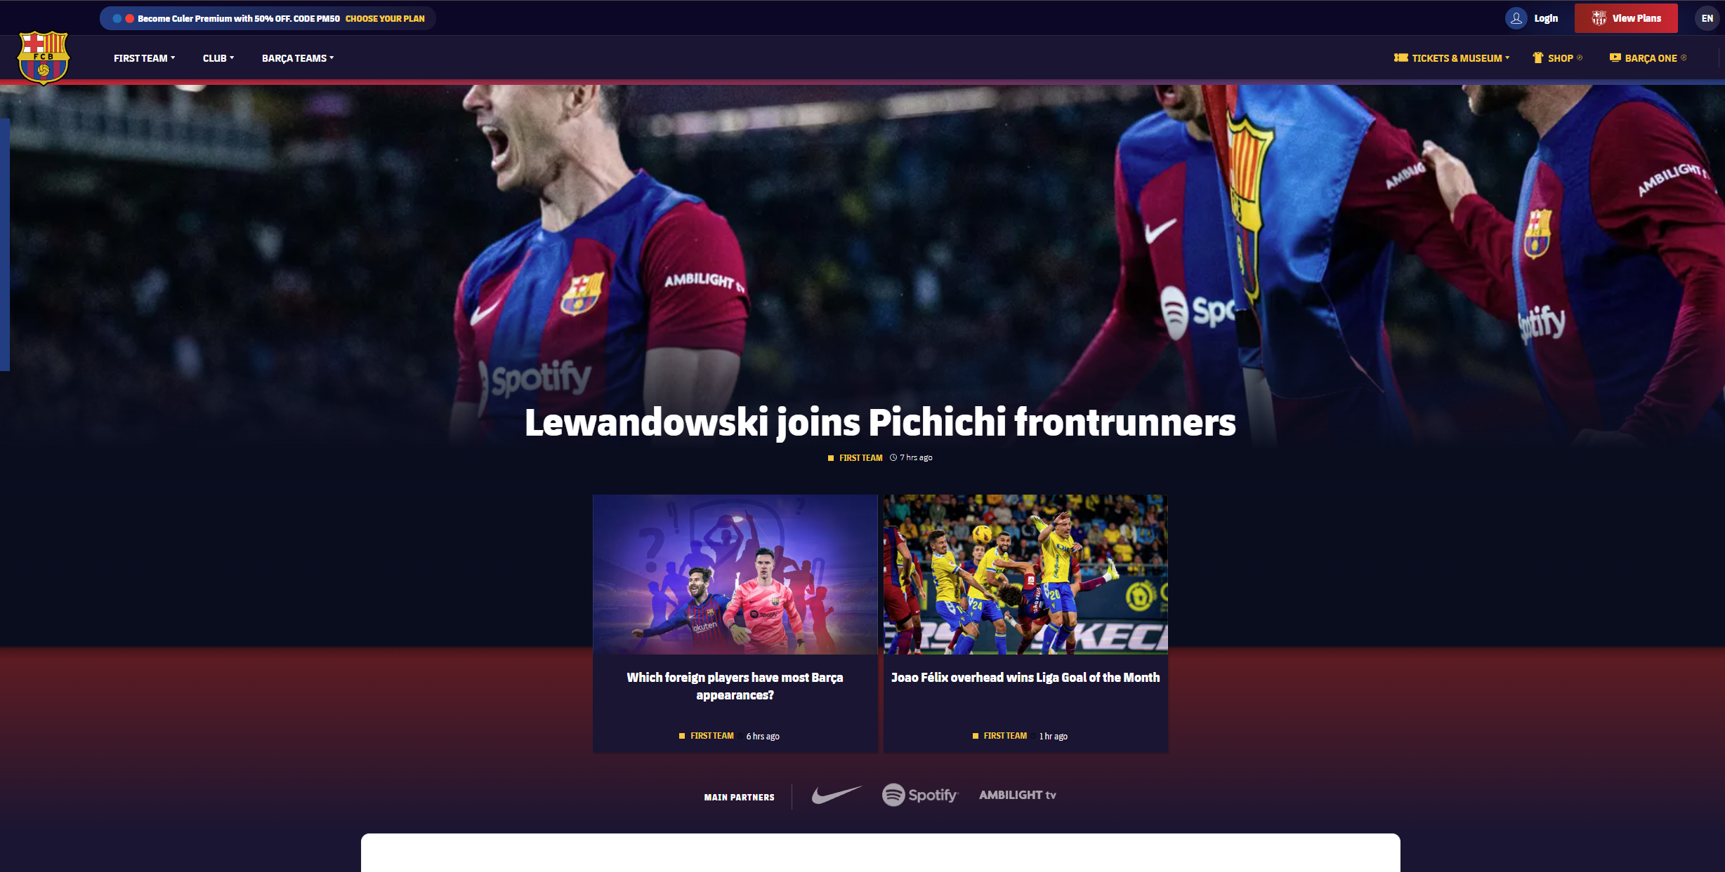

Figure 4: Inspiration Page

## **Planning Phase**

The initial idea was to build a website similar to the FC Barcelona official webpage. However, it wasn't very challenging and also didn't incorporate the information we gathered in the literature review. Therefore, we had to redefine the scope and refine the functionalities of the website. The assets I decided to retain from the original idea include the color palette, the players' names and images, and the palmares.

The key elemnts are:

**2.1 Main Page** with:

**Login/Register Area**: Prioritizing user engagement and personalization, a dedicated section for user authentication was maintained. This feature not only facilitates a tailored experience for returning visitors but also strengthens the community aspect of the website by enabling user interactions and personalizations.

**Language Switch (English/Spanish)**: Reflecting FC Barcelona's global fanbase and bilingual heritage, the inclusion of a language toggle ensures the website is accessible and welcoming to a wider audience. This decision underscores the project's commitment to inclusivity and user convenience.

**Navigation and Branding**: The main navigation bar, adorned with the FC Barcelona logo serving as a home button, ensures seamless navigation while reinforcing brand identity. This design choice exemplifies the project's attention to usability and brand consistency. The other links from the navigation bar are Club, Players next to the Logo and on the right Shop, Quizz, Fixtures.

**Social Media Integration**: A social media bar with active links to the club's platforms addresses the modern fan's desire to connect with the club across various digital landscapes. This feature leverages the power of social media to enhance fan engagement and community building.

**Content Strategy**: The main body's focus on selected articles allows for a curated content approach, providing fans with meaningful insights, news, and updates. This strategy ensures the website remains a valuable resource for fans seeking in-depth club information.

**Dynamic Footer**: Featuring details of the next game, including the rival's name and date, the footer keeps the content dynamic and relevant, encouraging repeat visits and ongoing engagement.

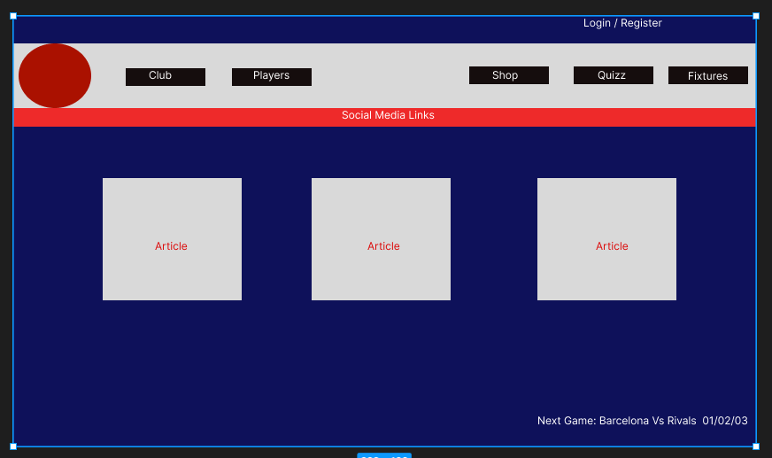

Figure 5 : Original Sketch

**2.2 Shop** serves as a dynamic online marketplace, designed to offer fans an intuitive and secure platform for purchasing official merchandise. Key functionalities include a versatile shopping cart system, facilitated by PHP sessions, allowing users to easily add items, adjust quantities, and review their selections. The integration of a MySQL database ensures that product listings are up-to-date, reflecting accurate prices, descriptions, and stock availability.

**2.3 The Fixture** area which is a pivotal section of the website designed to engage fans by providing a comprehensive and dynamic schedule of past and upcoming games. This section utilizes real-time data to update fans with scores, dates, and opponents, fostering a connection between the team and its supporters. The integration of an API to fetch live fixture data ensures that the information is both current and accurate, thereby enhancing the reliability of the website as a go-to source for fans. Serves as a functional element of the website but also significantly contributes to user engagement and loyalty.

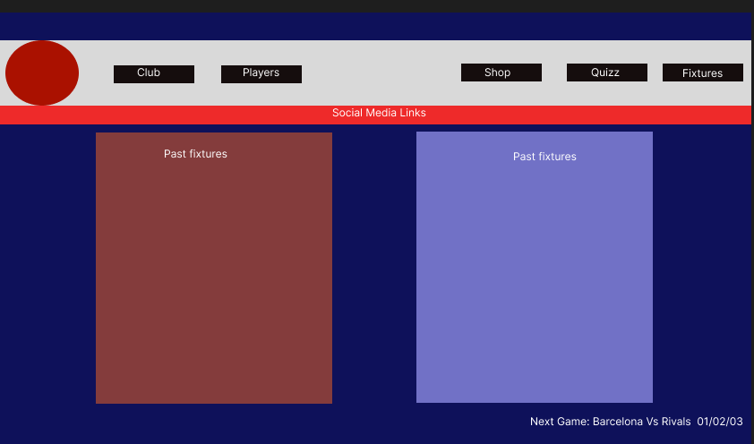

Figure 6 : Fixture Sketch

**2.4 The Quiz Game** segment, titled "Guess the Player," engages users in a fun and educational way, testing their knowledge of FC Barcelona players. This interactive quiz presents users with a player's image and multiple-choice answers, offering a dynamic challenge to fans.

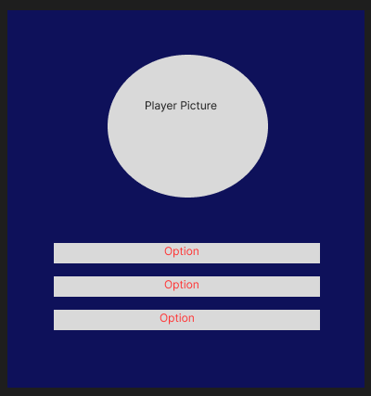

Figure 7 : Quiz Sketch

**2.5 Players** section feature serves as an immersive gateway for fans to explore detailed profiles of FC Barcelona players. Utilizing an interactive design with flip cards, fans can view player photographs and detailed information, including nationality and age, by flipping these cards. This section is designed to foster a deeper connection between the fans and the players, enhancing the fan experience through interactive engagement, also planning to demonstrate one of the Web design I have mentioned in the literature review and it is trending now Parallax scrolling.

## **Tools to be used.**

**3.1 Initial Design and Planning**

**Figma**: At the inception of the project, Figma served as the cornerstone for sketching and designing the website's layout and user interface. Known for its robustness and versatility in web design, Figma facilitated the seamless planning and visualization of webpage elements, enabling a collaborative and iterative design process.

**3.2 Content Development**

The narrative and textual components of the website were meticulously crafted to align with the overarching theme and tone appropriate for FC Barcelona's fanbase. This involved a thoughtful approach to writing content that resonates with the audience, engaging them with compelling articles, player profiles, and interactive quiz questions.

**3.3 Front-end Development Tools**

* **HTML**: The foundation of the website's structure, HTML, was utilized to organize the content across various pages, including the intricate player showcase and informative articles, all tailored to enhance the fans' experience.
* **CSS**: Custom stylesheets were meticulously crafted to ensure the website's aesthetic aligned with FC Barcelona's brand identity. CSS played a pivotal role in defining the visual theme, from the layout to interactive elements, creating a cohesive and visually appealing user interface.
* **JavaScript**: To infuse the website with dynamic features, JavaScript scripts were integrated, introducing interactivity such as the captivating parallax effects within the player showcase and the logic underpinning the interactive quizzes. These features significantly bolstered user engagement by enriching the website with lively and responsive elements.

**3.4 Back-end Development Tools**

* **PHP**: For server-side operations, PHP scripts were employed to manage critical functionalities, including the e-commerce capabilities within the shop and the user authentication system. PHP's versatility was instrumental in generating dynamic content, managing user sessions, and facilitating database interactions.
* **MySQL**: Serving as the backbone for data management, MySQL was deployed to efficiently organize, store, and retrieve essential data. This encompassed everything from user profile information to product details and quiz interactions, ensuring the website's content remained current and relevant.

## **Implementation**

The implementation phase of this project approaches to translate the initial design concepts into a fully functional website for FC Barcelona fans. This phase was characterized by the development of interactive features, content management, and user interface design, all aimed at providing an immersive user experience.

### **4.1 Main page**

**4.1.1 HTML Structure**

The Main Body is likely structured within the **index.php** file, utilizing HTML to lay out the content sections, such as news articles, player profiles, match highlights, and more.

* **Content Sections**: Each content piece, such as an article or a highlight, is encapsulated in **<div>** tags, classified by specific classes or IDs for styling and script interactions. This semantic HTML structure facilitates content organization and accessibility.
* **Dynamic Content Loading**: To keep the website fresh and engaging, content sections are designed to be dynamically loaded. This could involve placeholders within the HTML that are filled with content fetched from a database or an external API, based on the latest news, match results, or featured articles.

**4.1.2 CSS Styling**

Given the brand-centric approach, the **style.css** file ensures that the Main Body aligns visually with FC Barcelona's identity, employing the club's colour scheme, typography, and thematic elements.

* **Responsive Layouts**: The CSS rules are meticulously crafted to ensure content is accessible and aesthetically pleasing across devices. Media queries might be used to adjust layouts, font sizes, and image scaling, ensuring an optimal viewing experience on mobiles, tablets, and desktops.
* **Engagement Elements**: Highlighting features such as hover effects, transition animations, and dynamic content loaders enhance user interaction with the Main Body. These CSS-driven visual cues encourage users to engage with the content, be it through reading articles, viewing match highlights, or exploring player profiles.

**4.1.3 JavaScript Functionality**

JavaScript, potentially within **script.js** or a similar file, augments the Main Body with interactive and dynamic capabilities.

* **Interactive Components**: JavaScript enables interactive elements like sliders for match highlights, tabs for different content categories (e.g., News, Matches, Players), and modals for in-depth articles. These components allow users to navigate the Main Body's content intuitively and engage with their areas of interest.
* **Content Fetching and Rendering**: AJAX calls, fetching data from a server or third-party APIs, dynamically update the Main Body's content without requiring page reloads. This real-time content updating mechanism keeps the website's central hub vibrant and informative.
* **User Interaction Tracking**: JavaScript can also be used to track user interactions within the Main Body, such as article reads or video plays. This data, possibly analysed in conjunction with cookies or local storage, allows for a personalized content experience, tailoring the Main Body to reflect the user's interests and engagement patterns.

**4.1.4 Security and Performance**

* **Content Security**: Measures are in place to sanitize and validate dynamically loaded content, protecting against cross-site scripting (XSS) and ensuring that external links are secure.
* **Optimized Loading**: Lazy loading of images and content sections improves page load times and enhances user experience. JavaScript and server-side optimizations ensure that content is only loaded when needed, reducing unnecessary bandwidth usage and accelerating content delivery.

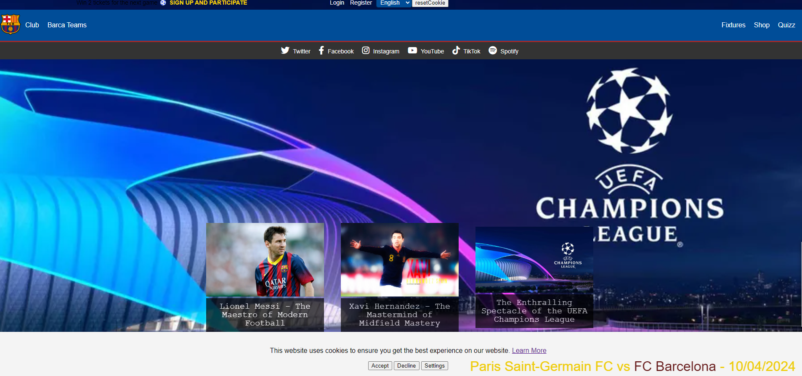

Figure 8: Main page with cookie

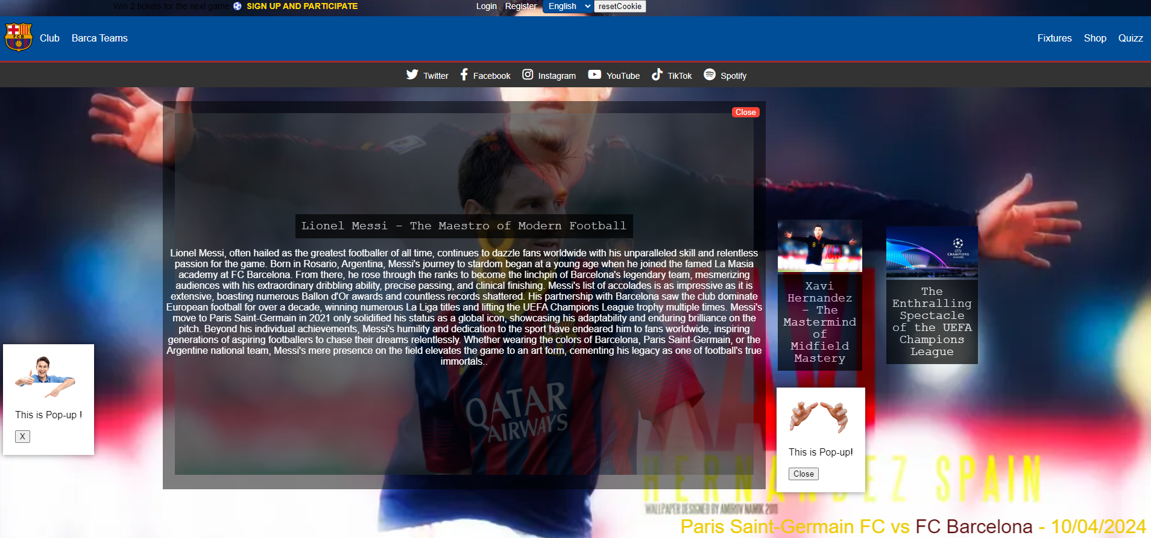

Figure 9: Main page with pop-ups and article expanded.

### **4.2 Shop**

**4.2.1 HTML Structure**

The shopping cart's core functionality is encapsulated within these PHP files, which handle the display and management of cart items, and interact with a database for product information.

* **Dynamic Product Listing**: **sh_cart.php** likely serves as the main interface for the shop, dynamically listing products fetched from a MySQL database. Products are displayed with details such as name, price, description, and an "Add to Cart" button.
* **Cart Management**: **cart.php** is responsible for the cart's backend logic. It handles sessions to track user-selected items across pages, processes additions or removals from the cart, updates item quantities, and calculates the total cost. It might also provide a checkout interface, allowing users to review their selections and proceed with the purchase.
* **Form Handling and Session Tracking**: Both files use PHP sessions to maintain cart state and HTML forms for user interactions, such as adding items to the cart or updating quantities. PHP's session management ensures that users' cart contents persist across different pages of the site until they decide to checkout or clear the cart.

**4.2.2 CSS Styling**

* **Styling for Usability and Brand Alignment**: The **cartStyle.css** file ensures that the shopping cart and product listings are not only functional but also visually appealing and aligned with the FC Barcelona brand. This includes styled product cards, buttons, and the cart summary page.
* **Responsive Design**: The stylesheet ensures that the shop is accessible and looks great on all devices, using responsive design techniques. This might involve flexible layouts, adaptable images, and media queries to adjust the styling for different screen sizes.

**4.2.3 JavaScript Enhancements**

While specific JavaScript files for the shop were not mentioned, interactive features such as live updates to the cart total when quantities are changed, or asynchronous requests to add items to the cart without reloading the page, can significantly enhance user experience.

* **Dynamic Interaction**: JavaScript can be used to update the cart dynamically, allowing users to see changes in real time as they add items or adjust quantities. This immediate feedback makes the shopping experience more interactive and engaging.
* **AJAX for Seamless Operations**: AJAX calls can interact with PHP backend scripts to update the cart contents on the server without needing to reload the page. This provides a smooth and seamless user experience, encouraging continued shopping.
* **Validation and User Feedback**: Client-side validation of form inputs, such as quantity fields, ensures that users input valid data. JavaScript can also provide immediate, inline feedback for such validations, improving usability.

**4.2.4 Security Considerations**

Security is paramount in e-commerce applications. The shopping cart implementation uses secure PHP sessions and incorporates best practices such as prepared statements for database interactions to prevent SQL injection. Input validation, both server-side and client-side, prevents common web vulnerabilities like cross-site scripting (XSS).

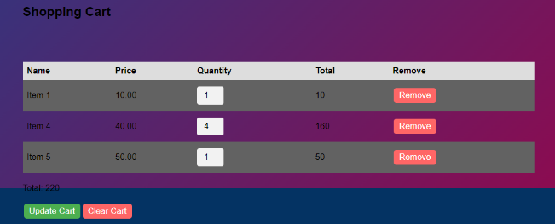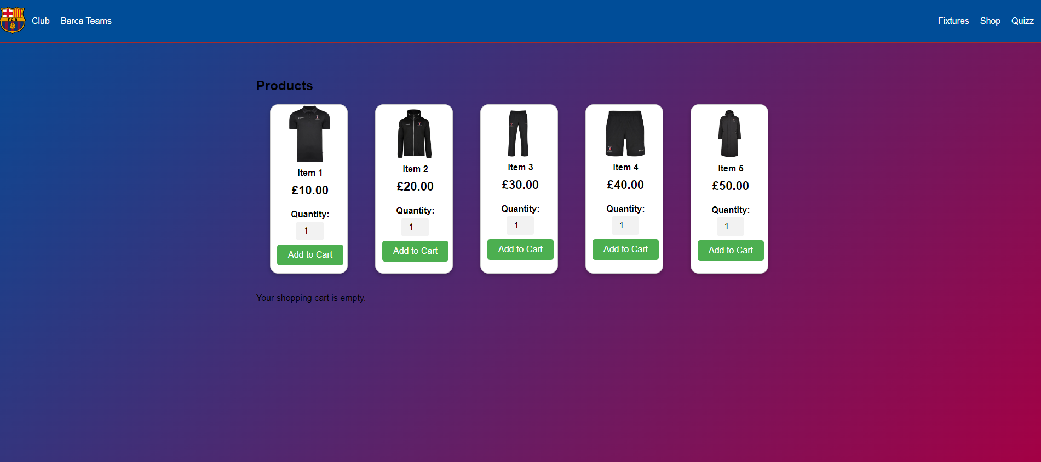

Figure 10: Shop items Figure 11: Shopping cart

### **4.3 Players Page**

**4.3.1 HTML Structure**

The HTML document lays the groundwork for an interactive and informative experience cantered around FC Barcelona's lineup, leveraging advanced web design techniques such as parallax scrolling and flip cards for player profiles.

* **Title and Introduction**: At the top, the page sets the stage with a title section and a brief introduction, inviting users to explore the team's lineup. This is complemented by the FC Barcelona logo, reinforcing brand identity.
* **Parallax Scrolling**: The page implements a parallax effect, creating a dynamic visual experience as users scroll. The **.parallax__layer--back** and **.parallax__layer--base** classes define elements that move at different speeds during scroll, enhancing the depth and interactivity of the presentation.
* **Player Flip Cards**: Each player is presented using a flip card design, with their image on the front and details like name, nationality, and age on the back. This interactive element is contained within sections for goalkeepers, defenders, midfielders, and attackers, allowing users to engage directly with player profiles.
* **Club History**: A dedicated section for the club's history showcases its achievements with trophy icons and descriptions, laid out in a timeline-style presentation. This segment not only celebrates the club's successes but also educates fans and visitors about its legacy.

**4.3.2 CSS Styling**

While the **style.css** content is not directly provided, its role is crucial in enhancing the aesthetics and functionality of the page, from the parallax effect to the responsive flip cards.

* **Responsive Design**: The stylesheet ensures that all page elements, especially the parallax layers and player flip cards, are responsive and accessible across a range of devices.
* **Visual Effects for Parallax and Flip Cards**: CSS techniques are applied to create the parallax background effect and the flip animation for player cards. This includes setting background images, controlling movement speed with transform properties for the parallax effect, and managing the flip animation's perspective and rotation for the cards.

**4.3.3 JavaScript Functionality**

The JavaScript file contains a simple yet effective script for the parallax scrolling effect, demonstrating how interactivity can be seamlessly integrated into the webpage.

* **Parallax Effect**: The script listens for the window's scroll event and adjusts the **translateY** property of the **.parallax__layer--back** element based on the scroll position. This creates a subtle but engaging parallax effect, where the background moves at a different speed than the rest of the page, adding depth to the user experience.

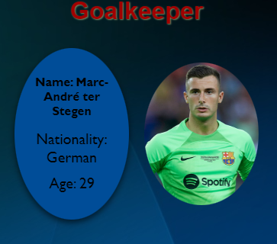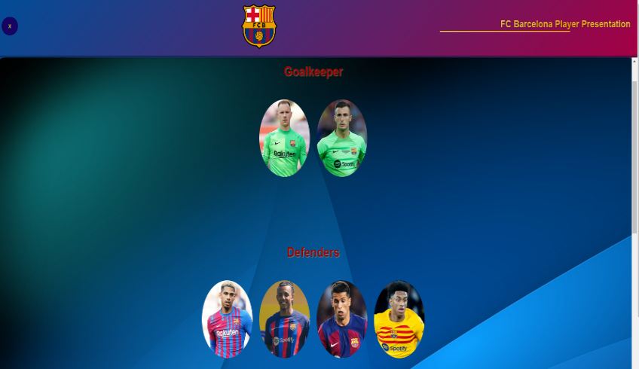 Figure 12: Player’s view Figure 13: Player card Front/Back

### **4.4 Fixtures**

**4.4.1 HTML Structure**

The Fixtures area is designed to provide fans with comprehensive and dynamic schedules of past and upcoming games.

* **Page Layout**: The **fixtures.html** document establishes the structure of the Fixtures area, which is divided into two main sections: "Past Fixtures" and "Upcoming Fixtures". Each section is contained within a **<div>** element, with child elements for each fixture that will be dynamically populated.
* **Dynamic Content Containers**: Inside each section, placeholder **<div>** elements are provided. These are intended to be filled with fixture data fetched from an external API. This approach allows for the content to be updated in real-time without manual intervention.
* **Navigation and Header**: The document also includes a navigation bar and a promotional header, enhancing user navigation and engagement with timely offers or announcements relevant to the fixtures.

**4.4.2 CSS Styling**

* **Visual Design**: The **style.css** file is responsible for the visual presentation of the Fixtures area. It defines the styling for the header, navigation bar, and the main content sections, ensuring a consistent and appealing look that aligns with the FC Barcelona brand identity.
* **Responsive Layout**: The CSS ensures that the Fixtures area is accessible and visually appealing across a range of devices. Media queries might be used to adjust the layout, font sizes, and element visibility, providing an optimal viewing experience on both desktop and mobile devices.
* **Highlighting and Separation**: Special styling is applied to differentiate between past and upcoming fixtures, such as varying colours, fonts, or border styles. This visual distinction helps users easily navigate the fixture schedule and focus on the matches of interest.

**4.4.3 JavaScript Functionality**

* **API Integration**: The core functionality of the Fixtures area is powered by JavaScript, particularly the integration with a football data API to fetch real-time fixture information. The **script.js** file contains functions to make asynchronous requests to the API, retrieve fixture data, and dynamically update the HTML content of the fixture’s sections.
* **Data Parsing and Display**: Upon receiving the fixture data, JavaScript functions parse the JSON response, extracting relevant information such as match dates, teams, scores, and locations. This data is then used to create new HTML elements or update existing ones, populating the "Past Fixtures" and "Upcoming Fixtures" sections with the latest information.
* **Dynamic Updates and User Interaction**: The script ensures that the Fixtures area remains dynamic and interactive. For example, clicking on a fixture might reveal more details about the match, such as player line-ups or match statistics. Additionally, the script could handle user actions like filtering fixtures by date or competition, enhancing the usability of the section.
* **Error Handling and Feedback**: Robust error handling mechanisms are implemented to manage scenarios where the API is unavailable or returns an error. Users are provided with clear feedback in such cases, ensuring a positive user experience even when external dependencies fail.

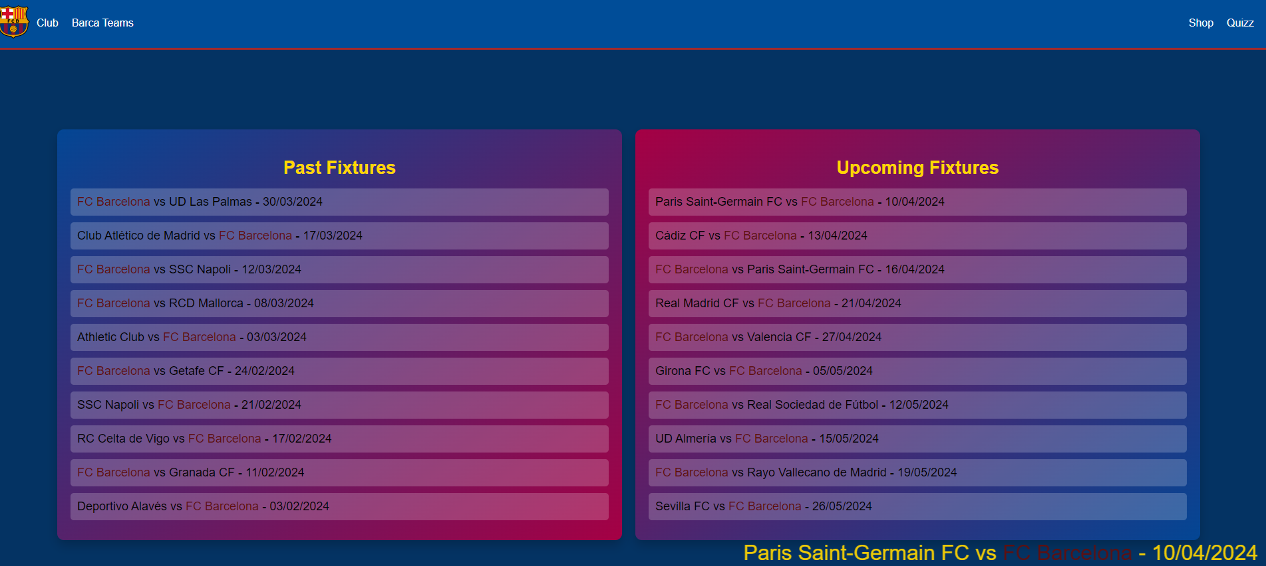

Figure 14: Fixtures

### **4.5 Quiz**

**4.5.1 HTML Structure**

* **Initial Screen**: The quiz begins with an initial screen that prompts users to start the game. This is implemented through a simple HTML structure featuring a button to "START PLAYING". Clicking this button triggers the JavaScript function **startGame()** to initialize the quiz.
* **Game Screen**: Once the game starts, the game screen is displayed with a dynamically loaded player image and multiple-choice answers. The HTML structure comprises a main **<div>** for the game area, including an **<img>** tag for the player image and several **<div>** elements for each answer option. Each option has an **onclick** event handler that invokes the **checkAnswer()** function with the option's index as an argument.
* **Final Screen**: After completing the quiz, the final screen is shown with the user's score. This section includes HTML elements to display the number of correct and incorrect answers, along with buttons to restart the game or return to the main page.

**4.5.2 CSS Styling**

* **Visual Design**: The **quizzCss.css** file provides the styling for the quiz, ensuring a visually appealing and intuitive user interface. It defines styles for the quiz container, image dimensions, answer options, buttons, and feedback indicators (correct or incorrect answers). Responsive design techniques ensure the quiz is accessible and engaging across various devices and screen sizes.
* **Feedback Indicators**: Special styles are used to highlight correct and incorrect answers, such as changing the background colour or border of the option selected by the user. These immediate visual cues enhance the interactivity of the quiz, providing instant feedback to the participants.

**4.5.3 JavaScript Interactivity**

* **Starting the Game**: The **startGame()** function initializes the quiz by resetting scores and displaying the first question. It hides the initial screen and shows the game screen.
* **Loading Questions**: The script dynamically loads questions and answer options into the game screen. This involves selecting a random player image and corresponding answer options from a predefined list, then updating the HTML content accordingly.
* **Answer Verification**: When a user selects an answer, the **checkAnswer()** function checks if the selection is correct. It updates the score accordingly and provides visual feedback by highlighting the selected answer in green (correct) or red (incorrect).
* **Progression and Scoring**: The quiz automatically progresses to the next question after an answer is selected, keeping track of the user's score. After all questions are answered, the final score is displayed on the final screen.
* **Restarting and Navigation**: Users can choose to restart the quiz or return to the main page at the end of the game. Functions tied to buttons on the final screen facilitate these actions, enhancing user engagement by encouraging repeated plays or exploration of other site features.

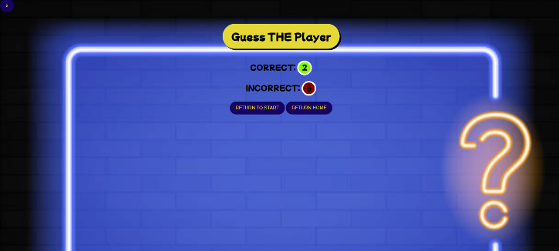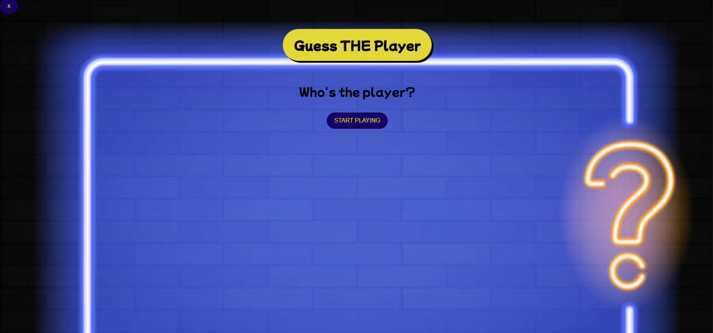

Figure 15: Quiz game start Figure 16: Quiz game end.

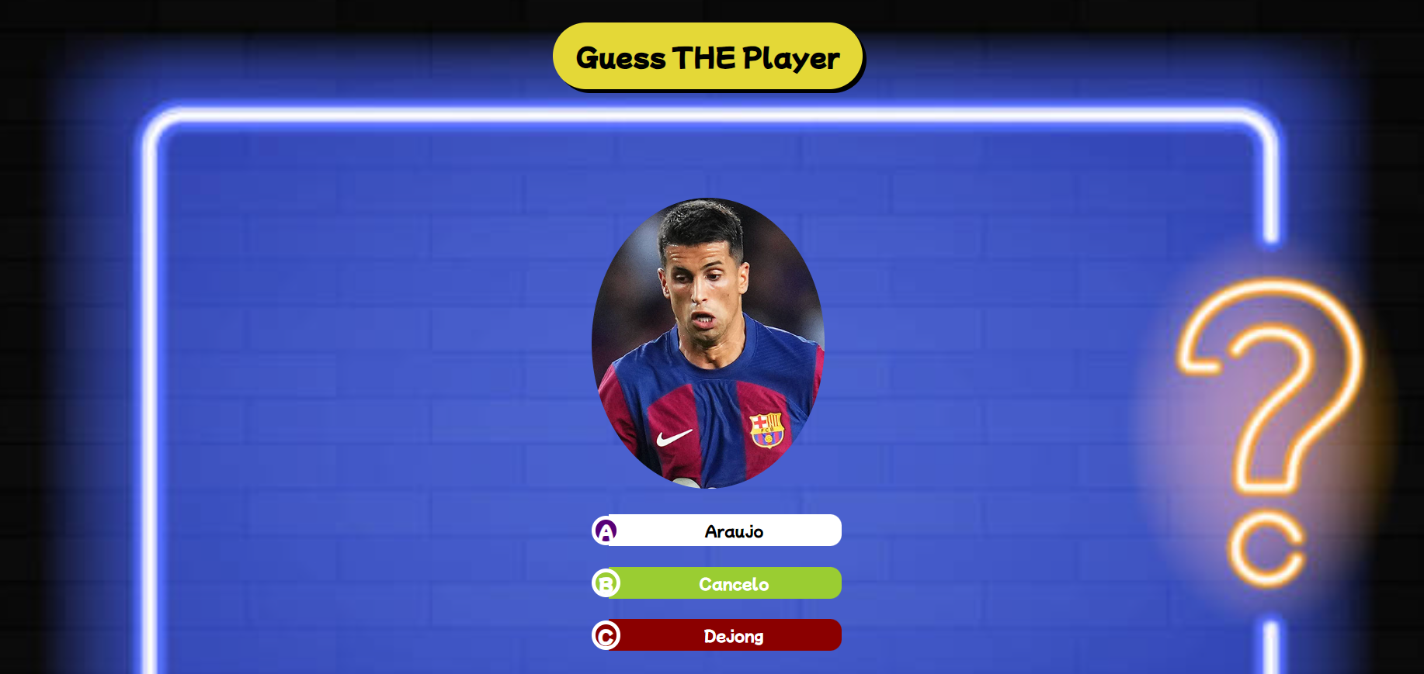

Figure 17: Quiz game exemple

## **Limitations**

**5.1 Technological Limitations**

* **Browser Compatibility:** One of the primary technological challenges in web design is ensuring compatibility across different browsers. With each browser interpreting code in its own way, designers often find themselves implementing workarounds or compromises to achieve consistent functionality and appearance. This not only complicates the design process but also limits the seamless integration of cutting-edge features that may not be uniformly supported.
* **Performance Constraints:** As web designs become more sophisticated, incorporating interactive elements and high-definition media, the impact on website performance becomes a significant concern. Designers must balance the desire for dynamic aesthetics with the need for fast loading times and responsive interactions.
* **Accessibility Challenges:** Ensuring web content is accessible to all users, including those with disabilities, remains a persistent challenge. Despite the guidelines provided by the Web Content Accessibility Guidelines (WCAG), achieving comprehensive accessibility can be daunting. Designers must navigate a complex array of requirements, from screen reader compatibility to keyboard navigation, which can constrain the creative process.

**5.2 Design Limitations**

* **User Experience (UX) Trade-offs:** In the pursuit of innovative design, the core principle of user-centric design can sometimes be overshadowed. Complex navigation schemes or unconventional layouts may intrigue some users but alienate others. The challenge lies in creating designs that are both unique and intuitive, offering a learning curve that does not detract from the overall usability.
* **Content Over Design:** The emphasis on visually striking designs can sometimes lead to the underestimation of content's role. A design-centric approach risks overshadowing the content, making it harder for users to find the information they need. Balancing aesthetic appeal with clear, accessible content is a nuanced aspect of web design that requires careful consideration.
* **Responsive Design Complexities:** With the array of devices used to access the web, responsive design is no longer optional. However, creating designs that adapt seamlessly to various screen sizes and orientations is inherently complex. Designers must consider a multitude of factors, from touch interfaces to varying resolutions, adding layers of complexity to the design process.

**5.3 Future Directions**

Despite these limitations, the field of web design is marked by continuous innovation. Emerging technologies like AI and machine learning offer new avenues for overcoming these challenges. For example, AI can assist in creating more adaptive designs, automatically adjusting content and layout based on user behaviours and device capabilities. Additionally, advances in web standards and browser technologies continue to reduce compatibility issues, making it easier to implement advanced features without compromising performance or accessibility.

# 

# **Chapter 4**

## **Conclusion**

This dissertation has embarked on a multifaceted exploration of the evolution of web design, juxtaposed with the dynamic landscape of user preferences, culminating in the practical application of these principles through the development of a fan engagement website for FC Barcelona. Throughout this journey, it has become evident that web design is not a static field but one that evolves in tandem with technological advancements, cultural shifts, and the ever-changing landscape of user expectations.

The historical overview of web design trends, from the rudimentary text-based interfaces of the early internet to the visually rich, interactive platforms of today, underscores the remarkable journey of digital innovation. This evolution reflects a broader narrative of how technology shapes and is shaped by human behaviour and societal needs. In delving into the past, we have gained insights into the fundamental principles that underpin effective web design: usability, aesthetic appeal, and the importance of creating engaging user experiences.

The practical component of this research, the development of a fan engagement website for FC Barcelona, served as a real-world application of the theoretical insights gained. By incorporating cutting-edge design techniques such as parallax scrolling, responsive layouts, and dynamic content, the project exemplified how contemporary web design practices can be leveraged to create meaningful and engaging online experiences. This endeavour not only highlighted the technical skills required for modern web development but also emphasized the creative and strategic thinking necessary to align design choices with user expectations and preferences.

This dissertation has underscored the dynamic interplay between technology, design, and user experience, highlighting the importance of adaptability, creativity, and user-centricity in the digital age. As we look to the future, it is clear that the field of web design will continue to be a critical arena for innovation, where the possibilities for enhancing human-digital interaction are boundless. In this rapidly evolving landscape, designers and developers must remain agile, continually seeking to understand and anticipate user needs, and leveraging technology to create web experiences that are engaging, inclusive, and impactful.

## **References**

1. A List Apart. (2024). *A List Apart*. [online] Available at: https://alistapart.com/ [Accessed 30 Apr. 2024].
2. Fcbarcelona.com. (2023). *Official FC Barcelona Website*. [online] Available at: https://www.fcbarcelona.com/en/ [Accessed 30 Ian. 2024].
3. Flashscore.co.uk. (2024). *Flashscore.co.uk: Football Live Scores, Latest Football Results - Premier League, Championship*. [online] Available at: https://www.flashscore.co.uk/ [Accessed 10 Ian. 2024].
4. Ford, R., Valérie Lavoyer, Wiethoff, A., Wiedemann, J. and Taschen (2019). *Web design : the evolution of the digital world 1990-today*. Köln: Taschen.
5. Garrett, J.J. (2011). *The elements of user experience : user-centered design for the Web and beyond*. 2nd ed. Berkeley, Ca: New Riders.
6. Jennifer Niederst Robbins (2018). *Learning web design : a beginner’s guide to HTML, CSS, Javascript, and web graphics*. Sebastopol, Ca: O’reilly.
7. Jongmans, E., Jeannot, F., Liang, L. and Dampérat, M. (2022). Impact of website visual design on user experience and website evaluation: the sequential mediating roles of usability and pleasure. *Journal of Marketing Management*, 38(17-18), pp.1–36. doi:https://doi.org/10.1080/0267257x.2022.2085315.
8. Kennedy, H. (2011). *Net Work*. Springer.
9. Krug, S. (2009). *Don’t Make Me Think*. Pearson Education.
10. Lara, C. (2023). *24 Top Web Design Trends 2024 | TheeDigital*. [online] TheeDigital. Available at: https://www.theedigital.com/blog/web-design-trends [Accessed 08 Mar. 2024].
11. Linearity.io. (2017). *Linearity: Ideate. Design. Animate. | Linearity*. [online] Available at: https://www.linearity.io/ [Accessed 08 Mar. 2024].
12. Marcotte, E. (2011). *Responsive web design*. New York: A Book Apart.
13. McFedries, P. (2019). *Web Design Playground*. Simon and Schuster.
14. *MyBib – A New FREE APA, Harvard, & MLA Citation Generator*. [online] Available at: https://www.mybib.com/#/projects/VvQMV0/citations [Accessed 30 Apr. 2024].
15. Niederst, J. (1999). *Web design in a nutshell : a desktop quick reference*. Beijing: O’reilly.
16. Nielsen, J. and Pernice, K. (2010). *Eyetracking Web Usability*. New Riders.
17. Peterson, C. (2014). *Learning responsive web design : a beginner’s guide*. Beijing: O’reilly.
18. Smashing Magazine. (2024). *Smashing Magazine — For Web Designers And Developers*. [online] Available at: https://www.smashingmagazine.com/ [Accessed 30 Apr. 2024].
19. Sustainable Web Design. (2024). *Home*. [online] Available at: https://sustainablewebdesign.org/ [Accessed 08 Mar. 2024].
20. Web Design Museum. (2024). *Web Design Museum - Discover old websites, apps and software*. [online] Available at: https://www.webdesignmuseum.org/ [Accessed 20 Feb. 2024].